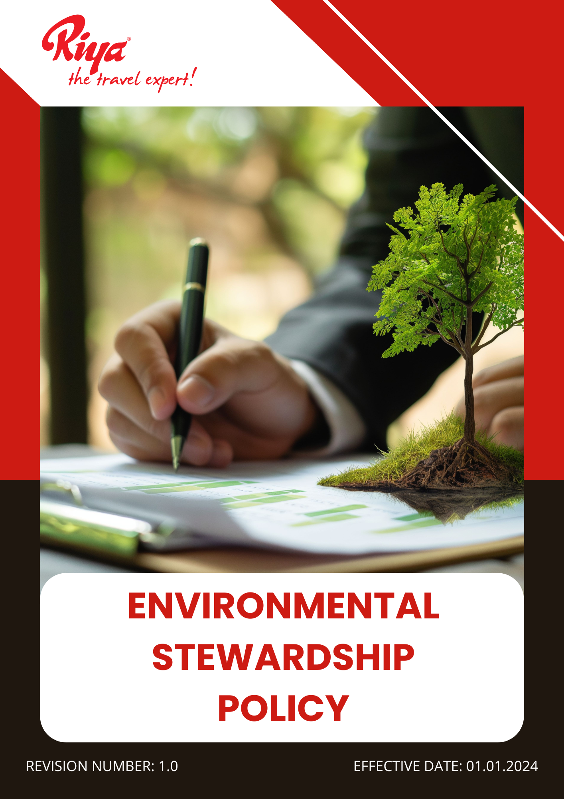

Contents
~ Overview 3
~ Purpose 3
~ Applicability 3
~ Policy statement 4
~ Our Focus Areas 4
~ Our Strategic Approach 4
~ Governance of this Policy 6
~ Responsibility for this Policy 7
~ Reporting 7
~ Continuous Improvement 8
~ Review Mechanism for this policy 9
~ Employee Acknowledgement Form 10

Overview
At Riya Travels and Tours Pvt ltd (Group), we recognize our responsibility to minimize our environmental impact and contribute to a sustainable future. As a leading travel service provider, we acknowledge that the tourism and travel industry plays a crucial role in environmental conservation. Our commitment to environmental stewardship is rooted in responsible business practices that aim to reduce carbon emissions, minimize waste, and promote eco-friendly travel solutions. Through sustainable procurement, energy-efficient operations, and awareness initiatives, we strive to make a positive impact on the environment while delivering high-quality services to our customers. This policy outlines our approach to integrating environmental sustainability into our business practices, ensuring compliance with relevant regulations, and fostering a culture of environmental responsibility within our organization and among our stakeholders.

Purpose
- Implement energy-efficient practices in office operations and advocate for carbon offset programs in travel services.
- Adopt paperless booking processes, reduce plastic use, and promote recycling initiatives within office spaces.
- Educate employees and travelers on responsible tourism and environmental best practices.
- Ensure adherence to local and international environmental laws while continuously improving sustainability efforts.
- Encourage eco-friendly travel options by partnering with sustainable airlines, hotels, and transportation providers.
- Prioritize eco-friendly and ethically sourced office supplies, travel packages, and vendor partnerships.
- Implement strategies to reduce water consumption in office spaces and promote water-saving practices among employees.
- Regularly assess and disclose the company’s environmental impact, setting targets for continuous improvement.

Applicability
This Environmental Stewardship Policy is applicable across all operations, business functions, and services of Riya Travel and Tours (India) Pvt Ltd (Group), covering all global locations, including corporate offices, registered offices, branch locations, subsidiaries, joint ventures, and associated supply chain activities. It applies to all employees, workers, contractors, and stakeholders connected to Riya Travel and Tours (India) Pvt Ltd (Group), whether directly or indirectly, and mandates strict adherence and accountability at every level.

Policy statement
Riya Travels is committed to environmental stewardship by integrating sustainable practices into our operations. We strive to minimize our ecological footprint, promote responsible tourism, and support environmental conservation. Through innovation and collaboration, we aim to reduce waste, enhance resource efficiency, and contribute to a greener future.

Our Focus Areas
- Minimizing waste generation and its environmental impact is a key priority.
- Lowering energy consumption and reducing greenhouse gas emissions remains a central focus.
- Responsible water use and conservation efforts are actively promoted.
- Customer health and safety are prioritized in all aspects of our operations.
- Maintaining a safe and healthy workplace for employees is an ongoing commitment.
- Advocating for environmental sustainability and promoting eco-friendly practices is integral to our mission.

Our Strategic Approach
- Sustainable Waste Practices
- We are going to promote digital ticketing, e-invoices, and online documentation to reduce paper usage by 30% by FY 2027-28 from the baseline year FY 2022-23.
- Efforts will be made to implement waste segregation at all office locations, set up labeled bins, and ensure proper disposal to achieve 100% waste sorting compliance by FY 2027-28.
- The company aims to phase out single-use plastics and use reusable office supplies to reduce plastic waste by 50% by FY 2027-28 from the baseline year FY 2022-23.
- Collaboration will be established with certified waste recyclers, e-waste collection programs, and responsible disposal agencies to ensure 100% compliance with waste regulations by FY 2027-28.
- Steps will be taken to encourage employees to reduce personal waste, promote bring-your-own-container initiatives, and introduce sustainable office pantry practices to minimize waste generation by 25% by FY 2027-28 from the baseline year FY 2022-23.
- Regular training will be provided on waste reduction, proper sorting, and eco-friendly habits to ensure 100% workforce participation by FY 2027-28.
- Energy Efficiency and Carbon Reduction
- To reduce overall energy consumption, we are installing energy-efficient LED lighting, smart sensors, and automated systems, aiming for a 20% reduction in office electricity usage by FY 2027-28 from the baseline year FY 2022-23.
- Commits to replacing conventional lighting with LED alternatives, installing motion sensors, and optimizing lighting use to reduce energy consumption by 20% by FY 2027-28 from the baseline year FY 2022-23.
- Plans are in place to upgrade office equipment with energy-efficient alternatives, improve air conditioning efficiency, and reduce standby power consumption to lower electricity usage by 15% by FY 2027-28 from the baseline year FY 2022-23.
- The company seeks to partner with renewable energy providers, explore solar power integration, and reduce reliance on fossil fuels to increase renewable energy usage by 40% by FY 2027-28.
- Plans to reduce total GHG emissions by improving energy efficiency in offices, using renewable energy where feasible, optimizing business travel, and encouraging virtual meetings, aiming for a 15% overall Scope 1-2-3 GHG emission reduction by FY 2027-28 from the baseline year FY 2022-23.
- Employees will undergo energy conservation and climate action training through awareness campaigns and best practice sharing, ensuring 100% workforce engagement by FY 2027-28.
- Water Stewardship and Efficiency
- We are committed to installing water-saving fixtures, such as low-flow faucets and dual-flush toilets, in all office locations to reduce water consumption by 20% by FY 2027-28 from the baseline year FY 2022-23.
- Water audits will be conducted regularly to detect leaks early and implement quick maintenance solutions, decreasing water wastage by 30% by FY 2027-28 from the baseline year FY 2022-23.
- Plan to promote rainwater conservation by collaborating with building management and encouraging the use of harvested rainwater for non-potable purposes, aiming to increase water efficiency by 15% by FY 2027-28 from the baseline year FY 2022-23.
- Plastic bottled water will be eliminated by encouraging refillable bottle use and providing filtered drinking water stations in all offices by FY 2027-28.
- Training sessions will be arranged to educate employees on water conservation, ensuring 100% participation in water-saving initiatives by FY 2027-28.
- Customer health and Safety
- The company plans to offer eco-friendly and hygienic travel choices by partnering with service providers that use non-toxic cleaning and sanitization methods, ensuring 100% safe travel experiences by FY 2027-28.
- Commits to providing customers with travel options that meet the highest health and safety standards, ensuring 100% compliance with global safety guidelines by FY 2027-28.
- Customer safety protocols will be strengthened by providing clear health guidelines, ensuring emergency preparedness, and offering 24/7 support, aiming for zero major safety incidents by FY 2027-28.
- Awareness sessions will be conducted for customers on travel safety, responsible tourism, and emergency preparedness to ensure 100% informed travelers by FY 2027-28.
- Environmental Service and Advocacy
- We are dedicated to offering eco-friendly travel packages, collaborating with sustainable tourism partners, and promoting responsible travel choices to ensure 30% of services are green-certified by FY 2027-28.
- Customers will be encouraged to adopt sustainable travel behaviours through green travel tips, carbon offset programs, and sustainability guidance, increasing customer participation in eco-friendly travel by 50% by FY 2027-28.
- Collaboration with environmental agencies will be established to conduct one or more sustainability training sessions, ensuring 100% of stakeholders, including suppliers, community, and partners, are educated and comply with eco-friendly standards by FY 2027-28.

Governance of this Policy
The governance of this Environmental Stewardship Policy will be overseen by a designated Sustainability Officer. This individual will ensure compliance with sustainability targets, monitor progress, and report on key environmental performance indicators. They will collaborate with all departments, stakeholders, and external partners to drive eco-friendly initiatives, implement best practices, and align operations with global environmental standards. Regular audits, training sessions, and policy updates will be conducted to foster continuous improvement. The Sustainability Officer will be accountable for integrating sustainability into corporate decision-making and driving long-term environmental responsibility.

Responsibility for this Policy
- Sustainability Officer
- Responsible for overseeing and review the implementation of the policy.
- Tracking progress on sustainability goals.
- Ensuring compliance with environmental regulations, and promoting continuous improvement.
- Senior Management
- Provides strategic direction, allocates necessary resources
- Integrates sustainability into corporate decision-making to drive long-term environmental responsibility.

- Employees
- Expected to adopt eco-friendly workplace practices, reduce waste, conserve energy and water
- Actively participate in sustainability initiatives.
- Procurement Team
- Ensures that all purchases prioritize sustainability by selecting eco-friendly, ethically sourced products and working with responsible suppliers.
- Facility Management
- Implements and maintains energy-efficient operations, waste segregation systems, and water conservation measures across all office locations.

Reporting
- Internal Reporting
- The Sustainability Officer will submit quarterly reports to senior management on policy implementation, progress, and key environmental performance indicators.
- Department heads will provide updates on sustainability initiatives, challenges, and corrective actions taken.
- Compliance Reporting
- Regular audits will be conducted to ensure adherence to environmental regulations and corporate sustainability commitments.
- Non-compliance incidents will be documented, investigated, and addressed through corrective measures.
- External Reporting
- An annual sustainability report will be published to communicate the company’s environmental impact, progress on targets, and future commitments.
- Reports will be shared with relevant stakeholders, including regulatory bodies, business partners, and customers.
- Employee and Stakeholder Feedback
- A reporting mechanism will be established for employees and stakeholders to raise concerns or suggest improvements related to environmental practices.
- Feedback will be reviewed regularly to enhance the effectiveness of the policy.

Continuous Improvement
We are committed to continuously enhancing our environmental stewardship efforts. We will regularly assess our sustainability strategies, integrate innovative eco-friendly solutions, and refine our policies based on industry advancements and stakeholder feedback. Through ongoing training, technological upgrades, and strategic partnerships, we will ensure sustained progress toward our environmental goals while adapting to emerging sustainability challenges.

Review Mechanism for this policy
The Sustainability Officer will review this policy every year or when needed to ensure its relevance and effectiveness. In collaboration with senior management and key stakeholders, they will evaluate progress, assess compliance, and identify areas for improvement. Adjustments will be made based on regulatory updates, operational changes, and sustainability advancements to maintain alignment with best practices and corporate goals.

Effective Date: 01.01.2024
Last Review Date: 01.01.2025

Next Review Date: 01.01.2026

Approved By – Director HR
(Riya Travels and Tours (India) Pvt ltd (Group))

Employee Acknowledgement Form
I acknowledge that I have received, read, and understood the Environmental Stewardship Policy. I understand my responsibility to comply with the policy’s guidelines and actively contribute to sustainability efforts within my role. I commit to adopting eco-friendly practices, reducing waste, conserving resources, and supporting the company’s environmental goals. I also recognize that the policy will be reviewed periodically, and I will stay informed about any updates. By signing this form, I confirm my commitment to upholding the principles outlined in the policy.

Employee Name: Mr. Milind Kadam
Department: IT
Designation: Team Leader

Date: 06/01/2025
Signature:

